Introduction to LangChain

The LangChain open-source Python framework streamlines the development of LLM applications. LangChain provides developers with components and interfaces to assist in integrating LLMs into their applications. The framework is used to pinpoint relevant information in text, ​such as a research paper or legal document. ​It also provides methods for responding to complex prompts by retrieving data and ​generating a coherent summary. ​It chains together the retrieval, extraction, processing, ​and generation operations from the large amounts of text and multiple sources, ​hence the word chain as part of its name.
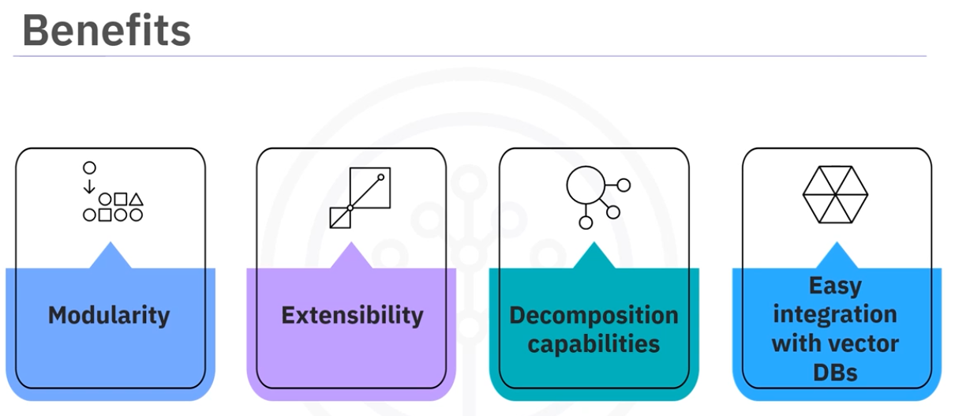
Let’s discuss each of these.
- Modularity - LangChain's design allows application developers ​to piece together different components like building blocks. ​This modularity also encourages component reuse, reducing development time and ​effort.
- Extensibility - ​LangChain's extensible design allows developers to readily add new features, ​adapt to existing components, integrate with external systems, and ​make only minimal changes to their codebases.
- Decomposition capabilities - ​LangChain mimics the human problem-solving process by breaking down complex queries ​or tasks into smaller, manageable steps. ​This decomposition capability enables it to make accurate inferences from context, ​resulting in relevant, precise responses.
- Easy integration with vector DBs - ​LangChain integrates with vector databases for efficient semantic searches and ​information retrieval. ​When used in conjunction with vector databases, it provides applications quick ​access to relevant information within extensive data sets.

- 